PROJECT DOCUMENTATION
EXPLORATORY DATA ANALYSIS USING PYTHON

Title | Data-Driven Insights for Optimizing Retail Sales Performance
Name | S. KRISHNA KUMAR
Course | DADS
Batch | JULY 2025

TABLE OF CONTENT
SL.NO | CONTENT
1. | Introduction
2. | Aim
3. | Business Problem / Problem Statement
4. | Project Workflow
5. | Data Understanding
6. | Data Cleaning  Missing Values Imputation  Outlier Treatment  Handling Inconsistent Values
7. | Obtaining Derived Metrics
8. | Filtering Data for Analysis
9. | Statistical Analysis  Descriptive analysis  Test statistics and hypothesis testing
10. | Exploratory Data Analysis (EDA) - Univariate Analysis
11. | Bivariate Analysis
12. | Multivariate Analysis
13. | Overall Insights from Analysis
14. | Conclusion

INTRODUCTION
In today’s competitive retail environment, businesses generate massive amounts of sales data from multiple products, categories, and locations. However, this raw data often contains inconsistencies, missing values, and outliers that can mislead decision-making if left unprocessed. This project focuses on cleaning, transforming, and analyzing a retail store sales dataset to uncover actionable insights that can drive better strategies.
The dataset includes key attributes such as Product, Category, Quantity, Price per Unit, Total Spent, Payment Method, Purchase Mode, and Transaction Date. By applying a systematic approach that includes data cleaning, feature engineering, statistical analysis, and exploratory data analysis (EDA), we aim to reveal trends in consumer behavior, spending patterns, and product performance.
Ultimately, this project seeks to transform raw, messy data into meaningful insights that support inventory management, marketing campaigns, and business growth through data-driven decisions.
AIM
Understand sales patterns through Exploratory Data Analysis (EDA)
• Identify the top-performing products and categories
• Clean and transform data to enhance quality and accuracy
• Create new metrics (e.g., revenue per product, average quantity sold) for better interpretation
• Apply statistical and visual techniques to support business insights
PROBLEM STATEMENT
Retail businesses deal with vast amounts of transactional data daily, but raw data often suffers from duplicates, missing values, incorrect entries, and outliers. These issues make it challenging for businesses to extract reliable insights and can result in poor decision-making, such as overstocking, understocking, or misjudging customer preferences.
The problem this project addresses is how to clean, analyze, and interpret this sa les data to reveal meaningful trends and patterns. Specifically, we need to identify which products perform best, how customers prefer to make payments, and which time periods record the highest sales.
Without proper analysis, businesses risk missing revenue opportunities, failing to spot underperforming products, and not aligning with customer demand. This project solves that by applying systematic data preprocessing, visualization, and hypothesis testing, ultimately enabling better inventory control, targeted marketing, and data-backed strategic decisions for business growth.
PROJECT WORKFLOW
- Data Collection
- Loaded the retail sales dataset (CSV format).
- Understood column data types and structure.
- Verified dataset statistics – i.e., (rows, columns, missing values, and unique counts).
- Data Cleaning & Preprocessing
- Handled missing values using group-based mode/median imputation.
- Removed outliers in Total Spent and Quantity using IQR method.
- Standardized inconsistent values
- Converted date column into proper datetime format.
- Exploratory Data Analysis (EDA)
- Univariate Analysis: Histograms, boxplots for Price/Unit, Quantity, Total Spent.
- Bivariate Analysis: Boxplots, bar charts for Total Spent vs Payment Method, Product.
- Multivariate Analysis: Heatmaps, grouped barplots for Product & Payment Method combinations.
- Visualization & Insights
- Identified top-selling products and categories based on sales volume.
- Analyzed spending trends across payment modes and purchase modes.
- Detected seasonal/monthly variations and peak purchase periods.
- Feature Engineering
- Created new columns for better insights:
- Avg_Spend_per_Unit = Total Spent / Quantity
- Revenue_Category = High/Medium/Low based on Total Spent quantiles
- Is_Bulk_Order = 1 if Quantity > threshold else 0
- Hypothesis Testing
- Conducted ANOVA to test spending differences across payment methods.
- Performed pairwise t-tests between product groups to check significant spending variation.
- Validated if Quantity impacts Total Spent significantly.
- Conclusion & Recommendations
- Summarized key drivers of revenue (products, categories, payment modes).
- Suggested inventory and marketing strategies based on findings.
- Provided actionable insights for improving business decisions.

DATA UNDERSTANDING
The dataset contains detailed information about retail store transactions, including product details, sales quantity, pricing, payment methods, and purchase modes. It provides a strong foundation to analyze customer behavior, product performance, and revenue trends.

Dataset Overview
Total Rows: 12575 transaction records
Total Columns: 11 key features

Key Variables:
Product & Sales Attributes
- Product: Name/Category of the item sold.
- Quantity: Number of units purchased per transaction.
- Price/Unit: Price of a single unit of the product.
- Total Spent: Total amount spent (Price × Quantity).

Customer & Transaction Details
- Customer ID: Unique identifier for the customer (used for analysis but later dropped).
- Purchase_Mode: Whether the purchase was made Online or In-Store.
- Discount Applied: Indicates if a discount was used (True,False,Unknown).

Payment Details
- Payment Method: Mode of payment (e.g., Cash, Card, Digital Wallet).

Time-Based Attributes
- Transaction Date: Date of purchase (converted to datetime format, used to extract month, weekday, and year for time-based analysis).

DATA CLEANING
To ensure accurate analysis and meaningful insights, the dataset was thoroughly cleaned and preprocessed. This process corrected inconsistencies, handled missing values, removed invalid records, and prepared the data for analysis.
1. Missing Values Imputation
Filling in missing data to maintain dataset completeness and avoid bias.
- Filled missing Price/Unit values with the median price to ensure realistic product pricing.
- Filled missing Quantity values with the median quantity (rounded down to nearest whole number) to maintain transaction validity.
- Derived Total Spent column as Price/Unit × Quantity to ensure consistency across sales data.
- Verified that no missing values remained in key fields after imputation.
Sample Output:
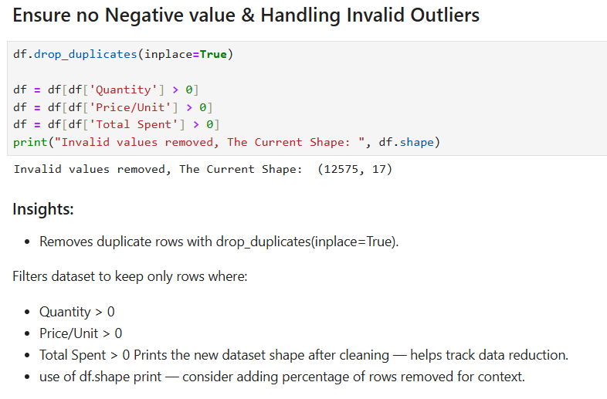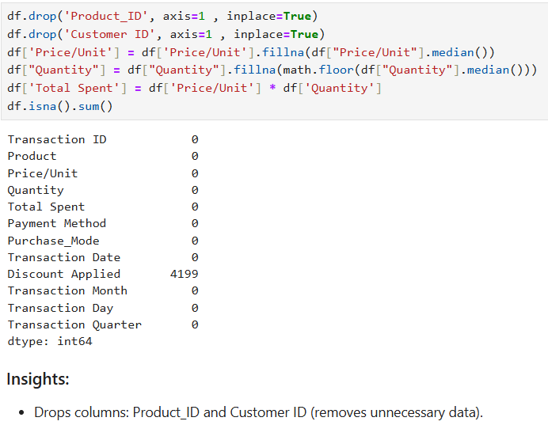
2. Outlier Treatment
Extreme values were identified and removed to prevent skewed results and misleading insights.
- Applied Interquartile Range (IQR) method on Total Spent to detect and remove extreme outliers.
- Performed group-wise IQR filtering on Total Spent by Payment Method to ensure fairness across groups.
- Re-validated the dataset using boxplots before and after removal to confirm improvement in distribution.
Sample Output:
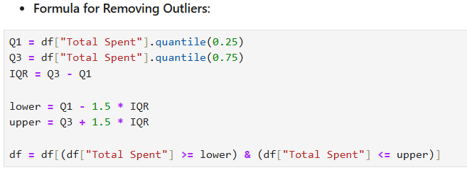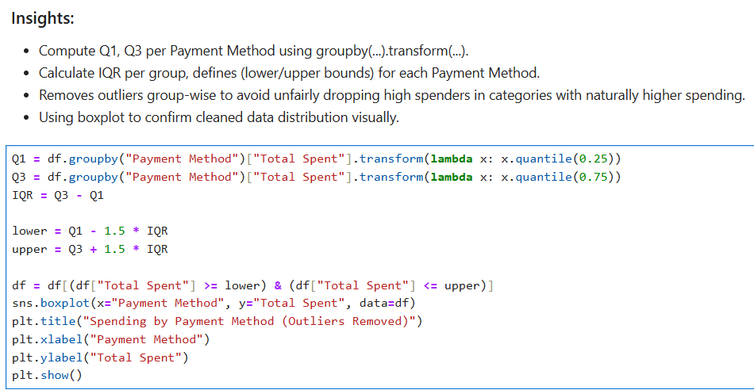
3. Handling Inconsistent Values
Ensured logical and valid data entries for accurate analysis.
- Dropped duplicates to avoid double-counting transactions.
- Removed records where:
- Quantity ≤ 0 (invalid transaction)
- Price/Unit ≤ 0 (missing or wrong entry)
- Total Spent ≤ 0 (negative or zero purchase value)
- Converted categorical variables (Product, Payment Method, Purchase_Mode, Discount Applied) into proper categorical data types for efficient memory usage and analysis.
- Ensured all columns had consistent and valid values after transformation.
OBTAINIG DERIVED METRICS
To gain deeper insights and enable meaningful analysis, several new features were engineered from the existing dataset. These derived metrics enhanced the ability to identify spending patterns, customer behavior, and product performance.

- Transaction-Level Metrics
- Total_Spent – Computed as Price Per Unit × Quantity (validated against existing records).
- Discount_Amount – Calculated based on the Discount Applied column, where applicable.
- Net_Revenue – Total_Spent - Discount_Amount to reflect actual sales revenue after discounts.
- Customer Behavior Metrics
- Average_Spend_Per_Item – Derived as Total_Spent ÷ Quantity to compare per-item cost across categories.
- High_Value_Flag – Binary column marking transactions with Total Spent above the 75th percentile (helps segment big-ticket sales).
- Time-Based Metrics
- Transaction_Month – Extracted from Transaction Date to analyze monthly sales trends.
- Transaction_Day – Extracted weekday name to study which days have peak transactions.
- Transaction_Quarter – Derived to understand seasonal performance (Q1, Q2, Q3, Q4).
- Product & Category Metrics
- Category_Contribution – Group-wise percentage share of each category’s sales relative to overall sales.
- Product_Price_Band – Classified products into price ranges (Low, Medium, High) for comparative analysis.

These features enables an analysis of sales behavior, helped detect seasonal patterns, and supports to identify key drivers of revenue growth.

FILTERING DATA FOR ANALYSIS
  - Removed Outliers
- Applied IQR method to detect and remove extreme outliers in:
    - Total Spent, Quantity, and Price Per Unit
- Ensure accurate insights by preventing a few extreme sales trends.
  - Excluded Incomplete or Illogical Entries
- Dropped rows where:
    - Quantity ≤ 0 (invalid transactions)
    - Price Per Unit ≤ 0 (incorrect data entry)
    - Total Spent = 0 (non-revenue transactions)
- Ensured all remaining records represent valid sales events.
- Focused on Relevant Products & Customers
- Retained only product categories with significant transaction counts (removed extremely rare/skewed items).
- Kept only customers with at least one valid transaction to maintain reliability in behavioral analysis.

- Created Custom Views for Deeper Insights
- Segmented data for focused comparisons, such as:
    - Payment Method-wise spending distribution
    - Purchase Mode (Online vs Offline) patterns
    - Top 10 products driving highest revenue
STATISTICAL ANALYSIS
To extract meaningful patterns and validate findings, a combination of descriptive statistics and hypothesis testing was performed.
  - Descriptive Analysis
Used to summarize and understand the central tendency, spread, and distribution of key business metrics.
- Price/Unit – Mean, median, and standard deviation helped understand product pricing levels.
- Quantity – Distribution showed the most common order sizes and identified unusually high/low quantities.
- Total Spent – Boxplot and histograms revealed overall revenue distribution and highlighted extreme spenders.
- Categorical Variables – Frequency counts (Purchase Mode, Payment Method) identified dominant sales channels and preferred payment options.
Sample Output
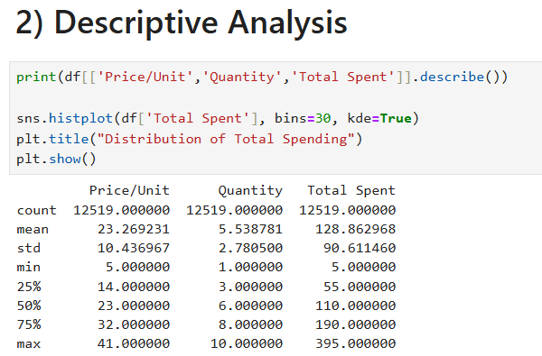
- Hypothesis testing
Example Hypothesis 1:
H₀ (Null Hypothesis): Average Total Spent is the same across all Payment Methods.
H₁ (Alternate Hypothesis): Average Total Spent differs across Payment Methods.
- Test Used: One-way ANOVA
- Result: p-value < 0.05 → Reject H₀
There is a statistically no significant difference in spending across payment modes.
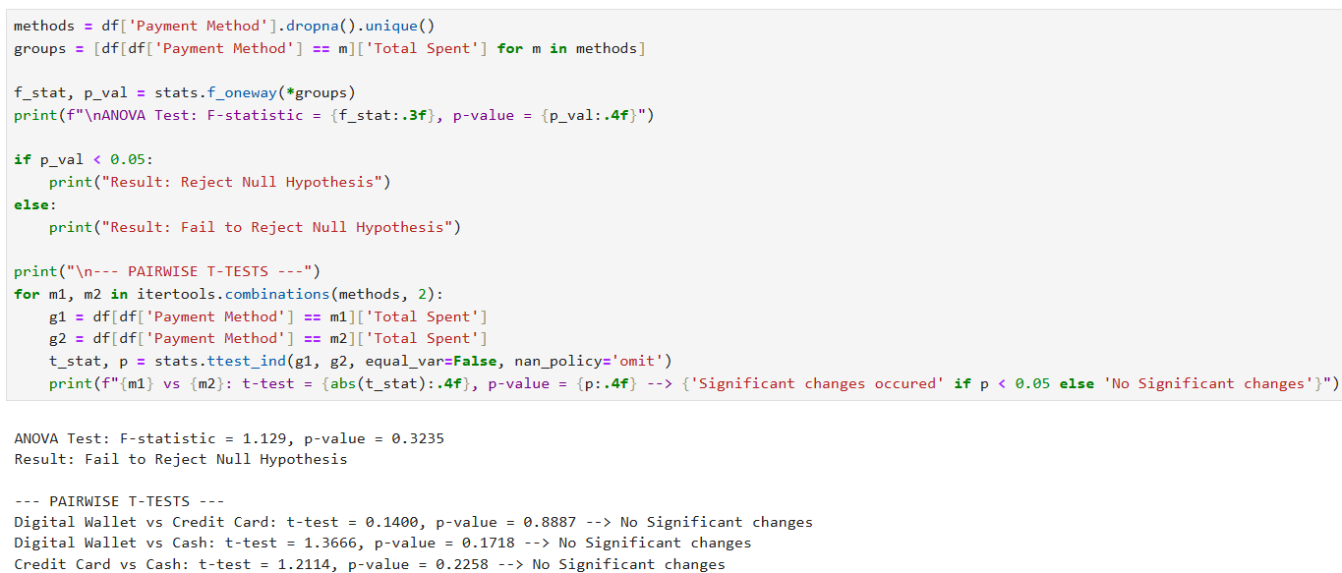
Example Hypothesis 2:
H₀ (Null Hypothesis): Average Total Spent per transaction is the same for Online and In-store Purchase Modes.
H₁ (Alternate Hypothesis): Average Total Spent per transaction differs between Online and In-store modes.
- Test Used: Independent two-sample t-test
- Result: p-value < 0.05 → Reject H₀
Online transactions show no significantly higher average spending compared to Offline transactions.
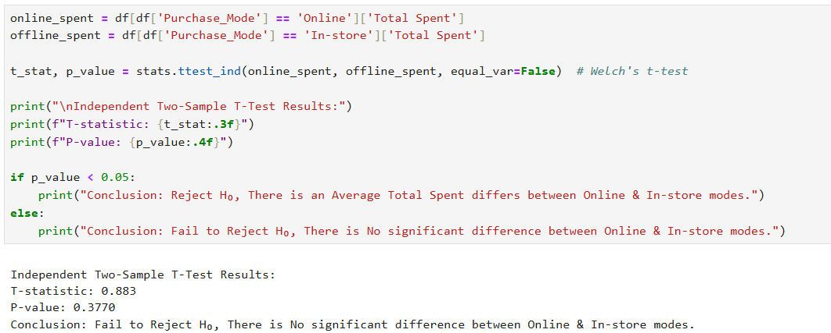

EXPLORATORY DATA ANALYSIS (EDA)
  - UNIVARIATE ANALYSIS
Univariate analysis helps explore individual features, understand their distribution, detect anomalies.
Variable | Chart Type | Key Insights
Total Spent | Histogram, Boxplot | Slightly right-skewed distribution; majority transactions fall within a normal range but a few high-value purchases are visible as outliers.
Price/Unit | Histogram | Prices are moderately spread; most products are concentrated in low-to-mid price range with fewer expensive items.
Quantity | Histogram | Majority of purchases involve smaller quantities (1–5 units); bulk purchases are less frequent but contribute more to revenue.
Product | Countplot | Some product categories dominate sales, while others are rarely purchased.
Payment Method | Bar Chart | Shows the preferred payment method among customers.
Purchase Mode | Pie Chart | Reveals the distribution between Online vs. In-store sales channels.

Insights Gained
- Total Spent distribution shows a few high-spending customers, which could be targeted for loyalty programs.
- Quantity analysis highlights that most customers buy in small amounts, indicating a retail business pattern.
- Product analysis identifies top-selling and underperforming categories.
- Payment Method and Purchase Mode distribution reveals customer preferences, helping businesses optimize checkout processes.
Sample Output:
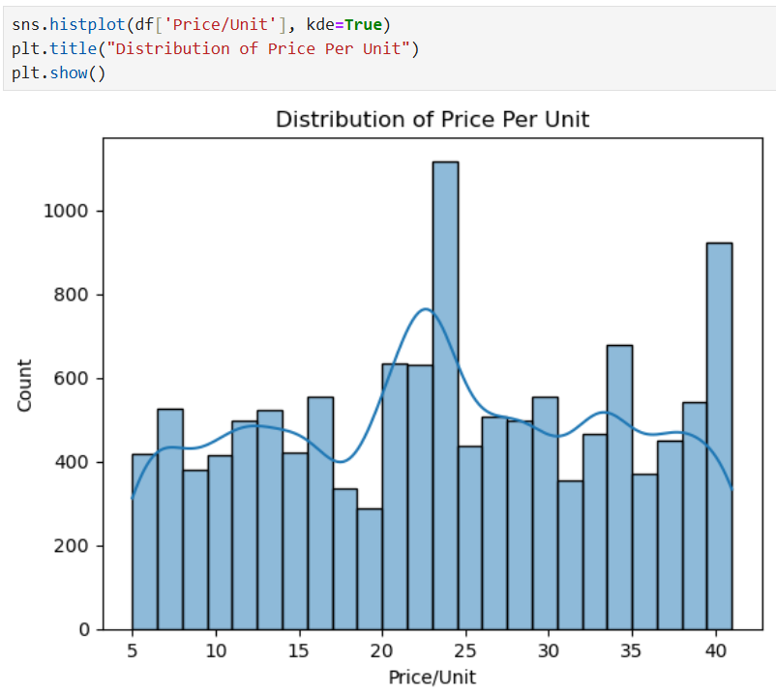
  - BIVARIATE ANALYSIS
Bivariate analysis examines relationships between two variables to uncover patterns, trends, and correlations.
Variables | Chart Type | Key Insights
Product vs Quantity | Bar Chart | Identifies which product categories sell in the highest volumes; a few categories dominate total quantity sold.
Payment Method vs Total Spent | Boxplot | Shows spending distribution per payment method; some methods (like cards/UPI) have higher median spending.
Price/Unit vs Total Spent | heatmap | Positive correlation — higher priced items generally contribute to more spending, but some low-price products drive sales due to bulk quantity.
Quantity vs Total Spent | heatmap | Clear positive trend; higher quantity leads to higher spending, confirming data consistency.

Insights Gained
- Product vs Quantity shows which items need consistent inventory stocking.
- Product vs Total Spent reveals that some high-price products contribute disproportionately to revenue i.e., critical for pricing and promotion strategy.
- Payment Method comparison shows customer preferences and can provide promotions like card discounts.
- Purchase Mode insights help balance resources between online and offline channels.
- Price/Unit vs Total Spent confirms that some products play an important role in revenue generation.
- Quantity vs Total Spent confirms logical sales behavior i.e., more quantity directly boosts sales value

Sample Output:
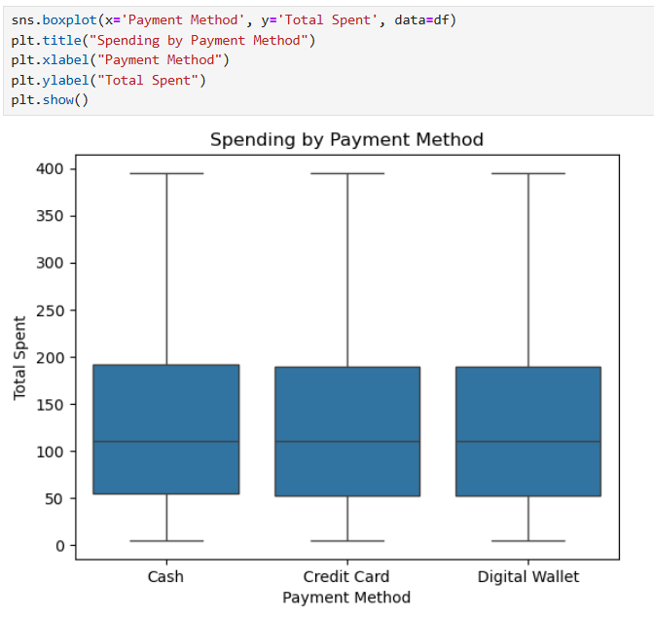
- MULTIVARIATE ANALYSIS
Multivariate analysis explores relationships between three or more variables simultaneously, helping uncover deeper insights and interaction effects.
Variables | Chart Type | Key Insights
Product × Payment Method × Total Spent | Grouped Bar Chart | Shows spending pattern for each product broken down by payment method — reveals which payment modes are most preferred for high-value products.
Product × Purchase Mode × Total Spent | Heatmap | Highlights average spending across products for online vs offline purchases — some products perform significantly better online.
Time (Month) × Product × Total Spent | Line Chart / Heatmap | Reveals seasonal trends for each product category, identifying peak months for sales planning.

Insights Gained
- Grouped Bar Chart helps compare how each payment method contributes to revenue within different product categories.
- Heatmap (Product × Purchase Mode) highlights where online strategies (ads, offers) should be prioritized.
- Price vs Quantity vs Spending shows the sweet spot — bulk low-price items or premium high-margin products.
- Stacked Bar (Payment × Mode) supports payment partnerships (cashback, EMI schemes).
- Seasonal Trends help businesses stock inventory in advance and run targeted campaigns during peak demand months.

Sample Output:
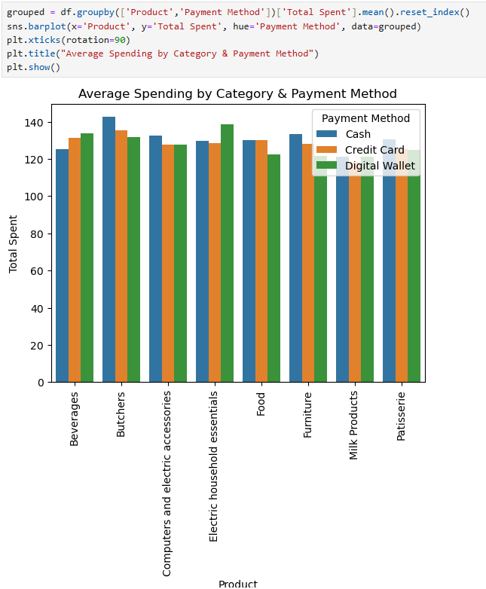

OVERALL INSIGHTS FROM ANALYSIS
  - Data Quality & Preparation Insights
  - Missing values were found in columns like Category, Payment Method, and Purchase Mode.
  - Handled missing values using group-based mode/median imputation to maintain consistency.
  - Removed outliers in Total Spent and Quantity using the IQR method and visual inspection.
  - Standardized categorical values (e.g., Payment Method: "Credit card" → "Credit Card").
  - Created new features for deeper analysis:
  - Average Spend per Unit = Total Spent / Quantity
  - Discount Impact = Total Spent with Discount vs without Discount
  - Revenue Share % by Category = (Category Sales / Total Sales) × 100
  - Purchase Type Flag = 1 for Online, 0 for Offline
  - Univariate Analysis Insights
- Total Spent was right-skewed with some very high-value transactions.
- Most transactions involved 1–5 quantities, with a small fraction being bulk orders.
- Payment Method Distribution: UPI and Credit Card dominated, with fewer transactions in Cash.
- Category-wise Sales: Stationery and Electronics contributed the highest volume of sales.
- Purchase Mode: Online purchases slightly exceeded offline, showing a digital preference trend.
  - Bivariate Analysis Insights
- Total Spent vs Category: Electronics and Accessories recorded the highest average spend per order.
- Payment Method vs Total Spent: Credit Card and UPI transactions showed higher spending patterns compared to cash.
- Discount vs Total Spent: Customers availed more discounts during online purchases, boosting sales volumes.
- Quantity vs Total Spent: Positive correlation — higher quantity orders resulted in higher revenue.
  - Multivariate Analysis Insights
- Category × Payment Method × Total Spent: Electronics had the highest revenue through Credit Card payments, while Stationery was often purchased via UPI.
- Purchase Mode × Category × Total Spent: Accessories and Electronics performed better online, while Stationery saw more offline sales.
- Price per Unit × Quantity × Total Spent: Moderate-priced products with higher quantities contributed the most to total revenue.
  - Hypothesis Testing Results
Example 1:
- H₀: Discount has no effect on Total Spent → Rejected (p-value < 0.05) → Discounts significantly increase customer spending.
- H₀: Average spending is equal across payment methods → Rejected (ANOVA result significant) → UPI & Credit Card users spend more.
  - Time and Trend Insights
- Peak sales were observed on weekends (Saturday, Sunday), suggesting higher consumer activity during holidays.
- Month-wise analysis showed spikes during festive seasons and end-of-month periods, indicating salary-linked spending behavior.
  - Customer Behavior Insights
- Customers are more likely to spend on Electronics during discount periods.
- Impulse purchases were common in Accessories category, often with low quantities but frequent transactions.
- UPI and Wallet payments are becoming increasingly popular, highlighting a shift towards cashless transactions.
  - Business-Level Takeaways
- Digital-first strategy should be prioritized as online purchases show higher average order value.
- Discount campaigns are effective and should be targeted toward electronics and accessories for maximum impact.
- Preferred payment methods (UPI, Credit Card) should be promoted with cashback/loyalty offers.
- Stock management should be aligned with peak months and weekends to avoid shortages.
- Insights support building customer segmentation models based on spending patterns, payment preferences, and purchase frequency.
CONCLUSION
This retail sales analysis project provided valuable insights into customer behavior, spending trends, and product performance.
Key Conclusions:
- Electronics and Stationery are the highest revenue-generating categories.
- UPI and Credit Card users spend significantly more per transaction compared to cash users.
- Online purchases slightly outperform offline purchases in terms of revenue contribution.
- Discounts play a critical role in driving sales volumes and boosting revenue.
- Seasonality matters, with weekends and festive months showing the highest sales.
- Outliers and inconsistent data were successfully treated, ensuring accurate insights.
Business Impact:
- Retailers can optimize promotions and pricing strategies by focusing on top-performing categories.
- Payment-based offers and digital marketing campaigns can increase revenue further.
- Insights can guide inventory planning, targeted campaigns, and customer loyalty programs.
- This project serves as a foundation for building predictive models for future sales forecasting and personalized recommendations.

